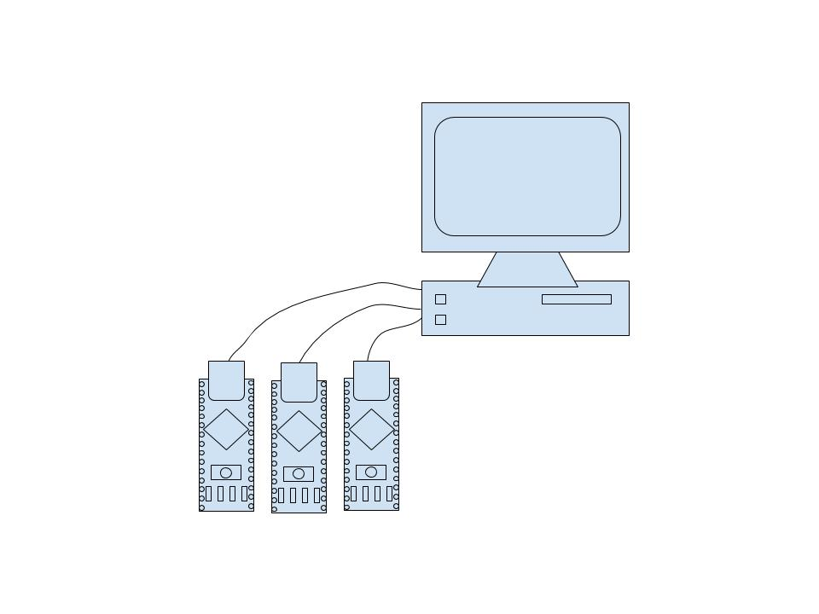

Figure : Arduinos can communicate with the computer via RS-232 USB connections

**Set-up:**

**Sensor Hubs:**

The sensor hubs consist of three Arduino Nano devices with ATmega328 CPUs. The Arduinos send data to the computer via RS-232 USB serial ports (figure 1). By running three separate program, the computer can read data from each Arduino simultaneously, allowing for a greater frequency of measurements. Each of the Arduinos connect to various commercial-grade sensors to collect environmental data. Although these sensors are cheaper than research-grade sensors, they are also less accurate; however, by calibrating them against a more expensive research-grade sensor their accuracy can be substantially improved. These sensors include:

1. BME 280: The BME 280 is an environmental sensor that collects data such as temperature, pressure, humidity, and altitude.
2. MGS001: This is a multichannel gas sensor that measures the concentration of various gases including NH3, CO, NO2, C3H8, C4H10, CH4, H2, and C2H5OH.
3. OPCN2: This sensor measures the concentration of particulate matter in the 10 micrometer range (PM10) and in the 2.5 micrometer range (PM2.5). This data gives valuable information about the concentration of pollutants.
4. SCD30: The SCD30 sensor measures CO2, temperature, and humidity.
5. PPD42NSDuo: This sensor records pollution data by measuring low pulse occupancy (LPO) time, the amount of time that any particle is detected. This measurement is proportional to the amount of PM concentration. By using pass-band filters, the PPD42NSDuo sensor can check the concentration of PM 2.5 as well as PM 10

In addition, the Arduinos are also connected to a camera. The image from this camera can be processed using machine learning in order to predict whether there is a cloud cover or not at any given time.